Creating a Persistent Disk
30 minutes1 Credit

Rate Lab

GSP004

Overview
Google Compute Engine lets you create and run virtual machines on Google infrastructure. You can create virtual machines running different operating systems, including multiple flavors of Linux (Debian, Ubuntu, Suse, Red Hat, CoreOS) and Windows Server!
Google Compute Engine provides persistent disks for use as the primary storage for your virtual machine instances. Like physical hard drives, persistent disks exist independently of the rest of your machine – if a virtual machine instance is deleted, the attached persistent disk continues to retain its data and can be attached to another instance.
There are 2 types of persistent disks:
- Standard persistent disk
- SSD Persistent disk
Learn more about the differences in Storage Options. Each type of persistent disks will have different capacity limits. Read more in the Persistent Disk documentation
In this hands-on lab you'll learn how to a create persistent disk and attach it to a virtual machine.

What you'll do
- Create a new VM instance and attach a persistent disk
- Format and mount a persistent disk

Prerequisites
- Familiarity with standard Linux text editors such as vim, emacs or nano will be helpful

Setup

Before you click the Start Lab button
Read these instructions. Labs are timed and you cannot pause them. The timer, which starts when you click Start Lab, shows how long Cloud resources will be made available to you.
This Qwiklabs hands-on lab lets you do the lab activities yourself in a real cloud environment, not in a simulation or demo environment. It does so by giving you new, temporary credentials that you use to sign in and access the Google Cloud Platform for the duration of the lab.

What you need
To complete this lab, you need:
- Access to a standard internet browser (Chrome browser recommended).
- Time to complete the lab.
Note: If you already have your own personal GCP account or project, do not use it for this lab.

How to start your lab and sign in to the Console
- Click the Start Lab button. If you need to pay for the lab, a pop-up opens for you to select your payment method. On the left is a panel populated with the temporary credentials that you must use for this lab.
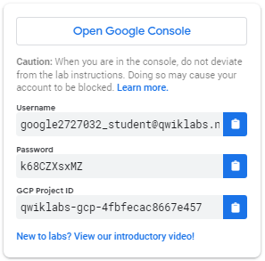
- Copy the username, and then click Open Google Console. The lab spins up resources, and then opens another tab that shows the Choose an account page.
Tip: Open the tabs in separate windows, side-by-side.
- On the Choose an account page, click Use Another Account.
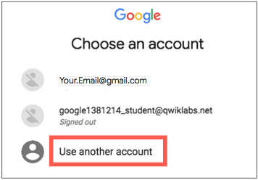
- The Sign in page opens. Paste the username that you copied from the Connection Details panel. Then copy and paste the password.
Important: You must use the credentials from the Connection Details panel. Do not use your Qwiklabs credentials. If you have your own GCP account, do not use it for this lab (avoids incurring charges).
- Click through the subsequent pages:
  - Accept the terms and conditions.
  - Do not add recovery options or two-factor authentication (because this is a temporary account).
  - Do not sign up for free trials.
After a few moments, the GCP console opens in this tab.
Note: You can view the menu with a list of GCP Products and Services by clicking the Navigation menu at the top-left, next to “Google Cloud Platform”. 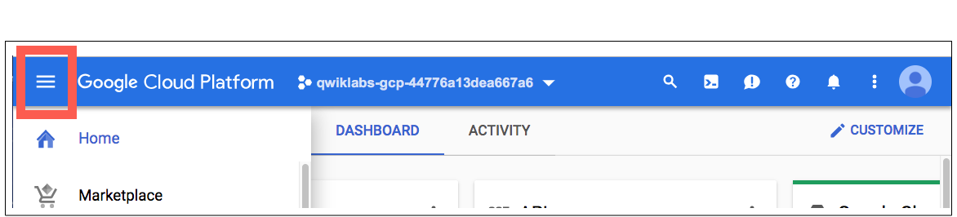

Activate Google Cloud Shell
Google Cloud Shell is a virtual machine that is loaded with development tools. It offers a persistent 5GB home directory and runs on the Google Cloud. Google Cloud Shell provides command-line access to your GCP resources.
- In GCP console, on the top right toolbar, click the Open Cloud Shell button.
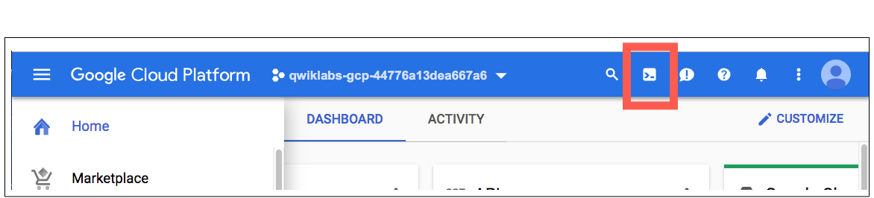
- In the dialog box that opens, click START CLOUD SHELL:
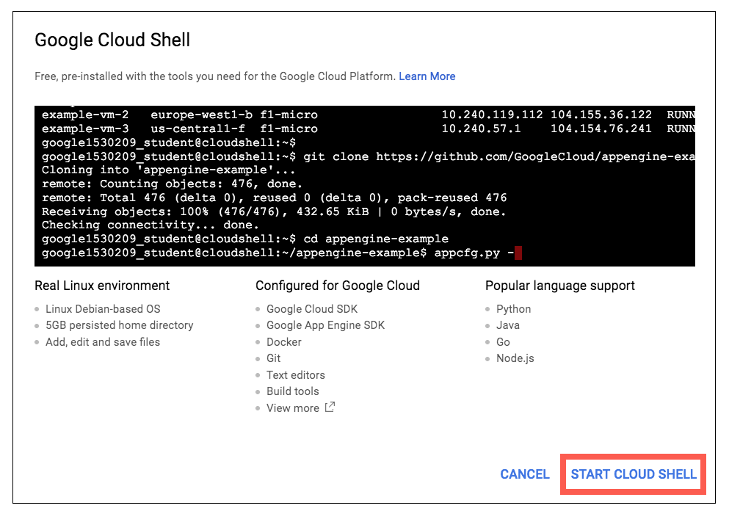
You can click "START CLOUD SHELL" immediately when the dialog box opens.
It takes a few moments to provision and connect to the environment. When you are connected, you are already authenticated, and the project is set to your PROJECT_ID. For example:
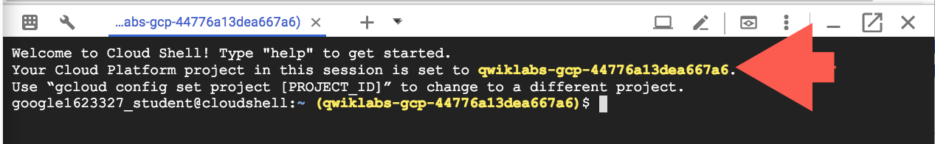
gcloud is the command-line tool for Google Cloud Platform. It comes pre-installed on Cloud Shell and supports tab-completion.
You can list the active account name with this command:
gcloud auth list
Output:
Credentialed accounts:
- <myaccount>@<mydomain>.com (active)
Example output:
Credentialed accounts:
- google1623327_student@qwiklabs.net
You can list the project ID with this command:
gcloud config list project
Output:
[core]
project = <project_ID>
Example output:
[core]
project = qwiklabs-gcp-44776a13dea667a6
Full documentation of gcloud is available on Google Cloud gcloud Overview.

Create a new instance
First, let's create a Compute Engine virtual machine instance that has only a boot disk.
You can learn more creating a virtual machine instance in a different lab, or refer to the Google Compute Engine documentation.
In Cloud Shell command line, use the gcloud command to create a new virtual machine instance named gcelab:
gcloud compute instances create gcelab --zone us-central1-c
(Output)
Created [...].
NAME ZONE MACHINE_TYPE PREEMPTIBLE INTERNAL_IP EXTERNAL_IP STATUS
gcelab us-central1-c n1-standard-1 10.240.X.X X.X.X.X RUNNING
The newly created virtual machine instance will have a default 10 GB persistent disk as the boot disk.
Click Check my progress to verify the objective.
Create a new instance in the specified zone.
Check my progress

Create a new persistent disk
Because we want to attach this disk to the virtual machine instance we created in the previous step, the zone must be the same.
Still in the Cloud Shell command line, use the following command to create a new disk named mydisk:
gcloud compute disks create mydisk --size=200GB \
--zone us-central1-c
(Output)
NAME ZONE SIZE_GB TYPE STATUS
mydisk us-central1-c 200 pd-standard READY
Click Check my progress to verify the objective.
Create a new persistent disk in the specified zone
Check my progress

Attaching a disk

Attaching the persistent disk
You can attach a disk to a running virtual machine. Let's attach the new disk (mydisk) to the virtual machine instance you just created (gcelab).
Use the following command to attach the disk:
gcloud compute instances attach-disk gcelab --disk mydisk --zone us-central1-c
(Output)
Updated [https://www.googleapis.com/compute/v1/projects/qwiklabs-gcp-d12e3215bb368ac5/zones/us-central1-c/instances/gcelab].
That's it!

Finding the persistent disk in the virtual machine
The persistent disk is now available as a block device in the virtual machine instance. Let's take a look.
- SSH into the virtual machine:
gcloud compute ssh gcelab --zone us-central1-c
(Output)
WARNING: The public SSH key file for gcloud does not exist.
WARNING: The private SSH key file for gcloud does not exist.
WARNING: You do not have an SSH key for gcloud.
WARNING: SSH keygen will be executed to generate a key.
This tool needs to create the directory
[/home/gcpstaging8246_student/.ssh] before being able to generate SSH
keys.
Do you want to continue (Y/n)? y
- At the prompt, enter y to continue.
- When prompted for an RSA key pair passphrase, press __enter __for no passphrase, and then press __enter __again to confirm no passphrase.
(Output)
Generating public/private rsa key pair.
Enter passphrase (empty for no passphrase):
Enter same passphrase again:
Your identification has been saved in /home/gcpstaging8246_student/.ssh/google_compute_en
gine.
Your public key has been saved in /home/gcpstaging8246_student/.ssh/google_compute_engine
.pub.
The key fingerprint is:
6c:04:bf:29:95:0d:93:bc:fe:00:2c:85:86:f8:7a:53 gcpstaging8246_student@cs-6000-devshell-v
m-dbb9559d-4412-4801-ad8c-bdaf885541a9
The key's randomart image is:
+---[RSA 2048]----+
| . . ...o. |
|. . o .oo= |
| . . o =.. |
| . E o+.o |
| . . ..oS |
|. o oo |
| . . o |
| . |
| |
+-----------------+
Updating project ssh metadata...\Updated [https://www.googleapis.com/compute/v1/projects/
qwiklabs-gcp-d12e3215bb368ac5].
Updating project ssh metadata...done.
Waiting for SSH key to propagate.
Warning: Permanently added 'compute.7714273689800906026' (ECDSA) to the list of known hosts.
Linux gcelab 4.9.0-4-amd64 #1 SMP Debian 4.9.51-1 (2017-09-28) x86_64
The programs included with the Debian GNU/Linux system are free software;
the exact distribution terms for each program are described in the
individual files in /usr/share/doc/*/copyright.
Debian GNU/Linux comes with ABSOLUTELY NO WARRANTY, to the extent
permitted by applicable law.
- Now find the disk device by listing the disk devices in /dev/disk/by-id/.
ls -l /dev/disk/by-id/
(Output)
lrwxrwxrwx 1 root root 9 Feb 27 02:24 google-persistent-disk-0 -> ../../sda
lrwxrwxrwx 1 root root 10 Feb 27 02:24 google-persistent-disk-0-part1 -> ../../sda1
lrwxrwxrwx 1 root root 9 Feb 27 02:25 google-persistent-disk-1 -> ../../sdb
lrwxrwxrwx 1 root root 9 Feb 27 02:24 scsi-0Google_PersistentDisk_persistent-disk-0 -> ../../sda
lrwxrwxrwx 1 root root 10 Feb 27 02:24 scsi-0Google_PersistentDisk_persistent-disk-0-part1 -> ../../sda1
lrwxrwxrwx 1 root root 9 Feb 27 02:25 scsi-0Google_PersistentDisk_persistent-disk-1 -> ../../sdb
You found the file, the default name is:
scsi-0Google_PersistentDisk_persistent-disk-1.
If you want a different device name, when you attach the disk, you would specify the device-name parameter. For example, to specify a device name, when you attach the disk you would use the command:
gcloud compute instances attach-disk gcelab --disk mydisk --device-name <YOUR_DEVICE_NAME> --zone us-central1-c

Formatting and mounting the persistent disk
Once you find the block device, you can partition the disk, format it, and then mount it using the following Linux utilities:
- mkfs: creates a filesystem
- mount: attaches to a filesystem
Make a mount point:
sudo mkdir /mnt/mydisk
Next, format the disk with a single ext4 filesystem using the mkfs tool. This command deletes all data from the specified disk:
sudo mkfs.ext4 -F -E lazy_itable_init=0,lazy_journal_init=0,discard /dev/disk/by-id/scsi-0Google_PersistentDisk_persistent-disk-1
Last lines of the output.
Allocating group tables: done
Writing inode tables: done
Creating journal (262144 blocks): done
Writing superblocks and filesystem accounting information: done
Now use the mount tool to mount the disk to the instance with the discard option enabled:
sudo mount -o discard,defaults /dev/disk/by-id/scsi-0Google_PersistentDisk_persistent-disk-1 /mnt/mydisk
That's it!

Automatically mount the disk on restart
By default the disk will not be remounted if your virtual machine restarts. To make sure the disk is remounted on restart, you need to add an entry into /etc/fstab.
Open /etc/fstab in nano to edit.
sudo nano /etc/fstab
Add the following below the line that starts with "UUID=..."
/dev/disk/by-id/scsi-0Google_PersistentDisk_persistent-disk-1 /mnt/mydisk ext4 defaults 1 1
/etc/fstab content should look like this:
UUID=e084c728-36b5-4806-bb9f-1dfb6a34b396 / ext4 defaults 1 1
/dev/disk/by-id/scsi-0Google_PersistentDisk_persistent-disk-1 /mnt/mydisk ext4 defaults 1 1
Save and exit nano by pressing Ctrl+o, Enter, Ctrl+x, in that order.
Click Check my progress to verify the objective.
Attaching and Mounting the persistent disk.
Check my progress

Test your knowledge
Test your knowledge about Google cloud Platform by taking our quiz.
Can you prevent the destruction of an attached persistent disk when the instance is deleted?
No, attached persistent disks are always associated with the lifetime of the instance
Yes, use the `–keep-disks` option with the `gcloud compute instances delete` command
Yes, deselect the option `Delete boot disk when instance is deleted` when creating an instance
Submit
For migrating data from a persistent disk to another region, reorder the following steps in which they should be performed:
- Attach disk
- Create disk
- Create snapshot
- Create instance
- Unmount file system(s)
Choose the correct order
(5, 3, 2, 4, 1)
(1, 3, 2, 4, 5)
(2, 3, 1, 4, 5)
(4, 1, 2, 3, 5)
Submit

Local SSDs
Google Compute Engine can also attach local SSDs. Local SSDs are physically attached to the server hosting the virtual machine instance to which they are mounted. This tight coupling offers superior performance, with very high input/output operations per second (IOPS) and very low latency compared to persistent disks.
Local SSD performance offers:
- Less than 1 ms of latency
- Up to 680,000 read IOPs and 360,000 write IOPs
These performance gains require certain trade-offs in availability, durability, and flexibility. Because of these trade-offs, local SSD storage is not automatically replicated and all data can be lost in the event of a host error or a user configuration error that makes the disk unreachable. Users must take extra precautions to backup their data.
This lab does not cover local SSDs. To maximize the local SSD performance, you'll need to use a special Linux image that supports NVMe. You can learn more about local SSDs in the Local SSD documentation.

Congratulations!
You've learned how to create, find, and attach persistent disks to a virtual machine instance and the key difference between persistent disks and local SSDs. You can use persistent disks to setup and configure your database servers.

